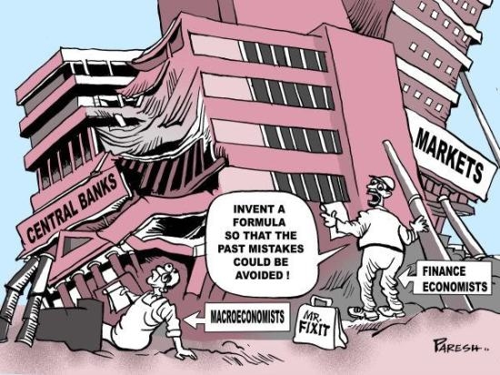

A DERAILED ECONOMY: Overview from Brazil
Ladislau Dowbor – PUC-SP
August 17, 2020
Economic theory has failed to clearly delineate the difference
between value creation and value extraction.
Mariana Mazzucato
Abstract: We are starting to see the outlines of a global slow-motion catastrophe, a view that no longer belongs to original analysts but is advocated by the world’s leading researchers. The convergence of major environmental issues, exploding inequality, political dismantling and financial chaos has generated renewed searches for novel paths. The pandemic comes on top of these challenges, possibly creating a movement towards systemic change. Humanity has been serving the markets well. It is time to bring the economy around, making sure it serves sustainable development.

In search of common sense
Pope Francis called on a global meeting in 2020 to address a new economy, symbolically named the Francesco Economy. The proposal is associated with the views of Saint Francis of Assisi. The city of Saint Francis where the meeting was to be held. It is being postponed because of the pandemic. But the discussion of the proposed issues, basically “another economy”, gave rise to a broad movement by portions of different religious and non-religious communities. The movement gained more visibility with the direct participation of personalities like Jeffrey Sachs, Joseph Stiglitz, Amartya Sen, Vandana Shiva, Mohammad Yunus, Kate Raworth, among other internationally prominent figures, including Nobel laureates. The tenet that the economy should serve society and not the other way round is resonating deeply within people. We live in an era of staggering uncertainties and the pursuit of new models. The current system, based on individual profit maximization and deregulated corporate giants, is simply not working.
The Francesco Economy (www.francescoeconomy.org) initiative aims “to make a commitment with the young people, beyond differences of beliefs and nationalities, to change the current economy and give a soul to that of tomorrow so that it is more just, sustainable and with active engagement by those who at present are excluded...Today more than ever, everything is deeply connected and the safeguarding of the environment cannot be divorced from ensuring justice for the poor and finding answers to the structural problems of the global economy. We need to correct models of growth incapable of guaranteeing respect for the environment, openness to life, concern for the family, social equality, the dignity of workers and the rights of future generations. Sadly, few have heard the appeal to acknowledge the gravity of the problems and, even more, to set in place a new economic model, the fruit of a culture of communion based on fraternity and equality.”
The idea is to rethink the role of the economy in society. After all, the economy should serve to improve our lives, rather than have billions struggling to access whatever “trickles down”. It seems there is a growing pressure for change, we must use good sense and reorder the arguments. An economy at the service of the common good should be economically viable, but also socially just and environmentally sustainable. This triple bottom-line defines a new balance and new forms of organization.
The challenge is not a lack of resources. The world currently produces US$85 trillion in goods and services per year, which, soundly distributed, would guarantee US$3,700 per month per family of four. And Brazil is precisely on the global average mark. What we today produce, with a reasonable reduction of inequality, is quite sufficient for a dignified and comfortable life for all. Our problem is not our production capacity but knowing what, to whom, and with how much environmental impact we produce. The real challenge is the system’s governance, a technical challenge, doubtlessly, but above all an ethical and political one. Our problem is not strictly economic, it basically a problem of political and social organization. We must change the rules.
The world before us is characterized by growing and dramatic inequality, where 1% hold more wealth than the other 99%, and 26 families have more than the poorer half of the population, 3.9 billion people. In Brazil, 6 families hold more wealth than the 105 million at the base of the pyramid. Inequality has reached unsustainable levels, in ethical, political, and economical terms.
Climate change, the devastation of life on earth and sea – we lost 52% of vertebrates in only 40 years – the loss of original forests, the general chemical contamination, the overflowing plastic residues and so many other destructive processes are leading to a widespread environmental catastrophe. We are facing the double challenge of reducing inequality by democratizing the economy and reducing the rhythm of destruction of the natural base of our survival by evolving to a sustainable circular economy. Presently we are destroying our vital environment for the benefit of the few. This is not working.
We know what must be done: the 17 sustainable development goals of the 2030 Agenda provide clear guidelines. We have the financial resources: in tax havens alone sit 20 trillion dollars, the result of tax evasions, corruption, and money laundering. This amount represents 200 times the 100 billion dollars a year that should be allocated for environmental policies, agreed upon during the Paris 2015 world summit. We have detailed information about each of the world’s problems. Our dramas have been pinpointed and quantified. And we also have the technology that now grants us the possibility to shift to other transportation modes, energy mixes, and productive processes. Our problem is not, therefore, the lack of means but the profound political deformations in the way we manage our economies.
The challenge lies in the decision-making processes, in how we define, regulate, and guide our use of resources. The economy must once again serve the interests of the common good. In the preliminary discussions during the preparation of the Brazilian participation in the event, beyond numbering the tragedies that assail us, we strove to concentrate on the organizational challenges. These are the challenges in governance. Meeting them will enable us to get back on our feet and halt the destruction of the planet to the benefit of a minority that accumulates unproductive capital.
The main topics we suggested for discussion, within the scope of the Economy of Francesco, are the following:
- Economic democracy: To recover corporate governance, create transparent information systems, and generate more balance between the State, corporations, and civil society organizations. There will be no political democracy if we do not reach basic economic democracy.

- Participative democracy: Decision-making about collective choices, about how we prioritize our use of resources, cannot depend solely on one vote every two or four years. With adequate information systems, decentralized management, and ample participation of the organized civil society, we must reach a new level of rationality in our economic and social organization. The new technologies and universal connectivity unlock immense potentials that must be explored.

- Taxation on financial flows: Taxation is crucial to ensure we have information on speculative capitals and guarantee that financial resources serve to finance inequality reduction and to stimulate sustainable productive processes. Tax systems should serve to improve distributive balance and resource productivity.

- Universal basic income: Within the broad view that access to basic goods and services should not be lacking to anyone, a simple and direct solution, especially with the modern transfer methods, is to ensure all adults have access to a basic income. These are not costs, since promoting simple consumption at the base of society boosts the economy and generates a corresponding return. This is not rewarding inactivity, it is about generating opportunities.

- Social policies for universal, public and free access: Access to health, education, culture, security, housing and other basic aspects of life should be within absolute priorities. These are not costs but investments in people, which boost productivity and making household resources available for other forms of consumption.

- Integrated local development: We are today essentially urban populations, and the fundamental policies that assure the well-being of communities and the sustainable management of natural resources must be rooted in each city, creating in this way economic, social, and environmental balance at the very base of society.

- Financial systems as a public service: The money managed by the financial systems comes from our savings and taxes. This is the population’s resources, and must, accordingly, respond to the needs of sustainable development. Public banks, community banks, credit cooperatives and other solutions such as virtual currencies are essential so that our choices can count on the corresponding resources.

- The knowledge economy: Knowledge constitutes today the main factor of production. As an immaterial and indefinitely replicable factor of production, it makes it possible to create a society not only adequately informed but also with universal and free access to the latest technological advances. We have to review the patent, copyright, and royalty rules of different types that unnecessarily block access to the advances. Knowledge is a factor of production that, unlike material goods, can be used and spread without generating new costs.

- Democratic communication mediums: As right-wing populism gains ground and democratic processes erode, it becomes clear how the communication medium oligopoly generates unsustainable distortions, leading to more profound political divides, hatred and prejudice. An informed society is fundamental for the economy to function for the common good.

- Pedagogy for economics: economics is essentially a set of rules agreed upon by society or imposed by interest groups. A democratic economy vitally depends on a generalized understanding of the mechanisms and rules of the economy. Obscure, pseudo-scientific curriculums must be substituted by tools for analyzing the real economy, so that we may form competent managers for an economy directed towards the common good.

These main lines of discussion focus essentially on decision-making processes, the tools of governance that society must have to recover the economic systems’ functionality. In this sense, they equally apply to productive activities such as manufacturing and agriculture and to social policies like healthcare and education. The philosophy here is based on the understanding that political democracy without economic democracy fails to work: the two worlds must recover their coherence. And given the worsening social, environmental, political and economic catastrophes, not only are these issues pressing but we are starting to see a major shift in attitude or at least a rising awareness.
Researchers and research centers are outlining a myriad of possible paths, and we may affirm that the theoretical bases of another economy are quickly being developed. Surpassing the old debate between orthodox and heterodox economic theory, a new pragmatism is arising, this time based on values, in the sense of the search for what works, regardless of the eternal ideological labels. We will see below some samples of the debate spreading across the world.

Mea Culpa
In September 2019, 181 of the world’s largest corporations signed a letter of agreement, redefining their goals and formally leaving behind their decades-long creed to increase the wealth of their shareholders without care for the systemic consequences, comfortably qualified as “externalities”. The text, agreed upon and disclosed by the BRT (Business Round Table), is short, basically five paragraphs. Below is the original text, updated on September 6, 2019:
“While each of our individual companies serves its own corporate purpose, we share a fundamental commitment to all of our stakeholders. We commit to:
- Delivering value to our customers. We will further the tradition of American companies leading the way in meeting or exceeding customer expectations.
- Investing in our employees. This starts with compensating them fairly and providing important benefits. It also includes supporting them through training and education that help develop new skills for a rapidly changing world. We foster diversity and inclusion, dignity and respect.
- Dealing fairly and ethically with our suppliers. We are dedicated to serving as good partners to the other companies, large and small, that help us meet our missions.
- Supporting the communities in which we work. We respect the people in our communities and protect the environment by embracing sustainable practices across our businesses.
- Generating long-term value for shareholders, who provide the capital that allows companies to invest, grow and innovate. We are committed to transparency and effective engagement with shareholders. Each of our stakeholders is essential. We commit to deliver value to all of them, for the future success of our companies, our communities and our country.”
They intend to satisfy consumer expectations, for sure, but also to invest in their employees – words such as “diversity and inclusion, dignity and respect” appear. This raises expectations among those who know how it is to work at Walmart or Amazon, or in Apple’s assembly lines in China. The commitment to deal ethically with suppliers, large or small, would also be a radical innovation. The fourth entry, to take responsibility for the impact produced on communities and the environment, making sustainability a goal, is essential, of course. But perhaps the most transformative one is the fifth-one, to further generate value for shareholders but within a systemic view that involves long-term commitments and the effects on communities. We know the current culture prioritizes maximum short-term returns, with little concern for the results to society.
Apparently, this is nothing deeply revolutionary, just plain good sense. But after 40 years of corporations hiding behind highly convenient theories like that of Milton Friedmann – “The business of business is business” –, entirely dedicated to bringing wealth to their shareholders, this letter calls attention. The large conglomerates have decided to take a turn. Or so they say.
Knowing how corporations work, Joseph Stiglitz shows moderate optimism: “In the last four decades, the prevailing philosophy in the United States has been that corporations should potentialize value for their shareholders – that is, increase profits and stock prices – right here right now, no matter what happens, without worrying about the consequences for workers, clients, suppliers, and communities. Therefore, the declaration in defense of conscious capitalism signed this month by almost all members of the Business Roundtable caused a commotion. After all, these are the chief executives of the United States’ most powerful companies, telling North Americans that the business world is much more than just balance sheets. And that’s a major turnaround, isn’t it?”
Cautious optimism seems adequate. But the truth is that the signatures of Bezos from Amazon, of CEOs from Apple, Johnson&Johnson, CityGroup and so many other major corporations, at the end of a letter that so radically reverts the last decades’ mantra, do not go by unnoticed. The almost 200 corporations that came together to make a public commitment to assume responsibility show, in any case, that they are feeling the change of tide. They reflect a world that is increasingly outraged with the chaos being produced.

Mea Maxima Culpa
Even more interesting is the statement made by 130 of the world’s largest banks affirming their intentions to follow six basic principles: to align their activities with the Sustainable Development Goals, including the Paris Climate Agreement; to ensure an open system of financial impact evaluation; to encourage their clients to undertake sustainable activities; to define social goals by consulting different social agents; to guarantee responsible internal governance; to create transparency tools so that the effects of their activities on society may be verified.
It is worth remembering that the 130 signatory banks represent 47 trillion dollars in assets, while the world GDP, in comparison, is around 85 trillion dollars. Seeing signatures of major loan sharks, like the main Brazilian banks, makes one skeptical, of course.

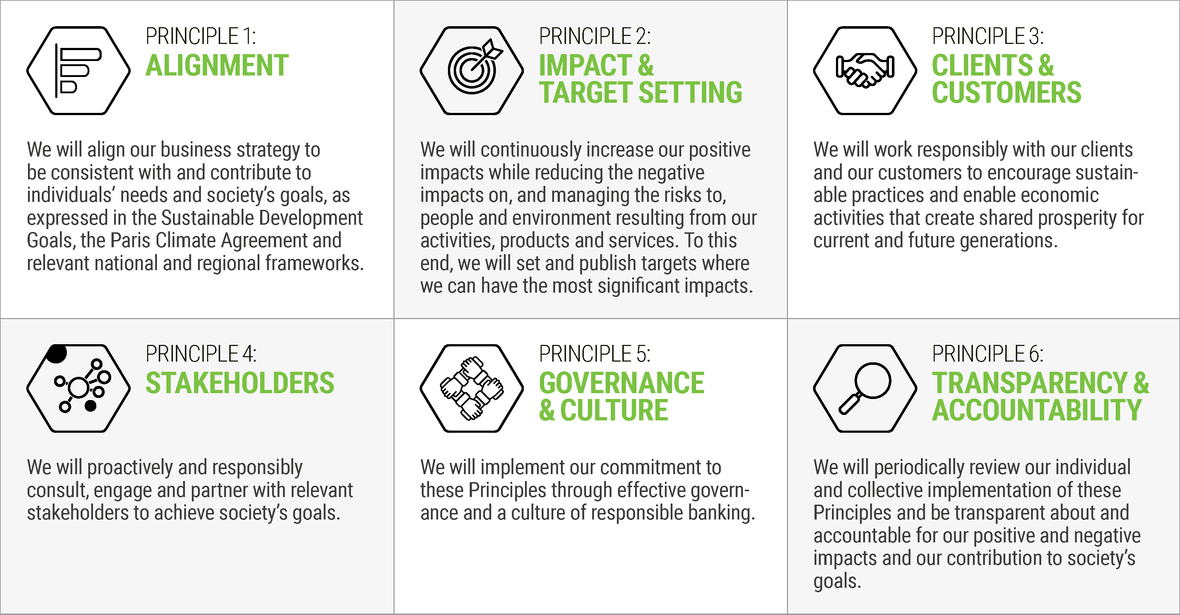

The fact is that large corporations conduct their activities on a global scale, where there is no government, regulation or rules to the game. We have a global economy, but no global government and only scant seldom respected rules. The largest corporations simply do not pay taxes, like in Brazil, where the profits and dividends distributed are exempt from taxation (since 1995). Environmental and social catastrophes are spreading, and inequality is reaching extreme levels. But banks are doing good. We have in tax-havens 200 times more financial resources than what the World Conference on Climate decided, and is barely able, to raise. Fraud in medication, food that causes obesity even in children, shady businesses in vehicle emissions, pesticides and antibiotics in our food – nothing is off-limits, since paying bank interest rates and dividends to financial investors like shareholders and other funds is an absolute priority in resource destination.
The truth is the outrage is growing. The economic, environmental and social impacts that corporations produce are their responsibility. After 40 years of irresponsible neoliberalism, are there any new paths? It’s healthy to show some skepticism. Corporate image manipulation is a long-standing tradition. But it is also a fact that corporations, especially banks, are feeling the heat of social indignation, as catastrophes become more visible and protests gain space.
These broad movements, like Pope Francis’s calling to action, the different social manifestations we see growing, and the corporate world’s defensive statements, open space for a set of new theoretical contributions that change the way economics has been developed and taught. These new ideas are gaining ample visibility. They are comfortably classified as “heterodox”, but they work, unlike the known orthodox views, which fundamentally justify corporate interest and have lead us to the current state of things.

New rules of the game
The study conducted by the Roosevelt Institute, New Rules for the 21st Century, is an important initiative. A strong statement sets the tone: “We handed our government over to markets and handed our markets over to corporations”. (p.8)
It’s a powerful reality shock, a synthesis of the paths the United States must trail so that the economy may once again serve society and not the other way round. It’s also a practical contribution, with a systematization of the main challenges and measures to be taken. The Roosevelt Institute is known for producing serious research and sensible proposals: “This report will illustrate the crucial need to curb corporate power and reclaim public power. We’ll show that deploying the two together is necessary to move our nation toward a future that borrows from the best of our history, amends previous mistakes, and adapts to modern times.” (10)
The report is also notable for not falling into ideological simplifications, clearly aiming for measures with proved utility. It presents the political dimensions of the challenges that we must face, rescuing the decision capacity over our resources, in a very helpful, straightforward manner. The problem is not the lack of resources but their diversion by corporations which drain the economy instead of boosting it, bringing public policies back. In other words, the report focuses on the main issues, corporate power and public policies. This is not valid only for the United States, of course. “We argue that generalizations about government inefficiency and ineffectiveness are overblown while the negative consequences of market-based solutions are too often overlooked… America has left a powerful government tool on the sidelines: direct public provision of goods and services.” (47/48)
Our impression from the report is that finally, the neoliberal wave is subsiding, not only in the left-wing corners of the world but in the big-league institutions. “For the last 50 years, we have disinvested in public power and told ourselves that government is the problem. We know that this is wrong. We also know that government is the basis for institutions and the tangible goods that are the very fabric of our everyday lives—schools and public safety; roads and bridges; safer food and drugs; cleaner air and water.” (63)
Avoiding polarization, the report shows that strengthening government is crucial even for the general economic functioning. “The combined effect of concentrated corporate power and corrupted public power has been devastating for our country… government is not investing in its people, in public programs, in technology, or in physical infrastructure—the type of investments that a strong, expanding economy requires.” (21) In the Brazilian case, ‘investing in the people’ is seen as ‘expenditure’. It is a sign that we have winds of change blowing, when a Financial Times editorial (April 4, 2020) states that “governments will have to play a more active part in the economy. They should see public services as investments.”
In my interpretation, it is a reality shock meant to get capitalism back on track. I’ve been qualifying this pursuit as ‘civilized capitalism’. The document itself suggests a ‘progressive world-view’, but its proposals radically differ from neoliberalism: “History has not been kind to neoliberalism, that grab-bag of ideas based on the fundamentalist notion that markets are self-correcting, allocate resources efficiently, and serve the public interest well. Learning the lesson that neoliberalism was always a political doctrine serving special interests may be the silver lining in the cloud now hanging over the global economy.” (1) It is sobering to see such ideas in a document signed, among others, by Joseph Stiglitz, ex chief economist of the Clinton administration and the World Bank.
The special interests are, of course, the corporations, which became rent-extracting machines, draining the economy instead of contributing to it: “Because so much of corporate power is directed at “rent-extraction” – getting a larger share of the nation’s economic pie by taking advantage of others – rather than at wealth creation, curbing corporate power will even lead to a stronger overall economy.” (3) We have here the evident result of financialization. The process worsened when politics was overtaken: “Ultimately, this allowed the very wealthy to convert their economic power into concentrated political power that, in turn, allowed them to further tilt the rules in their favor and capture more economic power.” (7) This is the hellish machine: financial power generating political power that in turn makes it possible to distort laws to generate more financial power.
Thus, “this private sector free-for-all jeopardized the well-being of individuals and communities across the US, but it also jeopardized economic growth, as it allowed the super-rich to draw profits from rent-seeking and other activities that enhance their own wealth without growing the economy.” (7) The system clearly distanced itself from productive contributions: “Markups, or the amount that a company charges above cost, have risen since 1980 from 18 percent above marginal cost to 67 percent. This suggests that corporate profits comprise not productive returns to capital and labor but rents.” (10) That is, we essentially pay financial investments: “Before the 1970s, American corporations paid 50 percent of profits to shareholders and the rest was invested back into the business. Today, shareholder payments sit at 90 percent of reported profits (Mason 2015a).” (17)
The report insists on the consequences of reclaiming productivity in the financial sector. “In order to ensure that finance’s function is socially beneficial, reform of the financial sector should seek, above all, to reduce macroeconomic risk and curb predatory practices. Further, reforms should aim to increase productive lending, which could grow small businesses that currently face capital constraints, facilitate efficient, low-cost plain vanilla loans, and serve unbanked and underbanked households that are currently being exploited by high-fee lenders.” (39)
In our case in Brazil, banks themselves behave as loan sharks at an incomparably more pernicious level. Having the problem of reclaiming the social and economic productivity of financial intermediaries presented in such a clear manner is nonetheless useful. “Despite technological advances that should have made the financial industry – an “intermediary” service – less expensive and more competitive over time, the unit cost of finance today is as high as it was in 1900, because the financial sector does not pass these savings on to consumers but rather boosts profits.” (24)
The authors also highlight the key importance of a strong public financial system to stimulate the quality of the services provided by the markets: “The fact that the public provision of basic financial services might crowd out predatory private providers is not a bug but a feature of the design. In essence, public options discipline markets to ensure access, quality, and quantity of essential goods and services.” (54) We need regulation, but we also need public companies, which directly provide goods and services and thus counterweight and limit loan shark practices and financial rent-extraction, providing alternatives to the population. For us in Brazil, entangled as we are amid privatizations, the notion that the public sector is essential to increase the private sector’s performance is important.
The document as a whole aims to recover the role of the public sector. “Policymakers should deploy the power of the government, through direct public provision, with two key goals at the forefront of a new progressive worldview: universal access to goods and services and transformative investment in the pursuit of national goals.” (51) By inverting the neoliberal narrative, the text shows that the greatest systemic productivity is reached when governments take the role of policy providers and shows the fallacy of austerity: “In fact, there is evidence that spending too little costs much more in the end (in terms of damage to human lives and to economic growth) than spending too much.” (13)
In Brazil, we experience this firsthand, since the lack of access to public policies forces people to resort to much more expensive private services. This results in a loss of systemic productivity. It is worth remembering that the World Bank qualified the years from 2003 to 2013 as the “Golden Decade” of the Brazilian economy. Income and access to goods and services increased significantly. This boosted the economy and limited the deficit by increasing revenue. Our deficit gains significance with the beginning of the austerity era in 2014. For more detail, see chapter 12 of my The Age of Unproductive Capital, available at http://dowbor.org.
According to the Roosevelt Institute report, “Public provision, executed with attention to underlying market dynamics and the landscape of race and gender inequality, should be the default mechanism for providing goods and services that are essential for human dignity and agency, such as access to housing, health care, and banking. Direct public provision is essential in cases where the public has a strong interest in universal access and private sector providers can exert market power over those seeking access. There are economic justifications for using government power to provide essential goods and services. A vast literature outlines the economic benefits of providing individuals with a baseline level of services that include childcare, early education, and pensions. Most notably, increased investments in people work to increase economic productivity overall.” (52)
The change, in the authors’ views, will not come without a transformation in corporate decision-making, in the so-called corporate governance. “To create a system that serves the interests of all stakeholders, not just those of executives and the investment community, corporate boards should be required to include, at a minimum, a substantial proportion of workers as well as representatives of other non-shareholder corporate stakeholders.” (37) The text shows how this works in Germany and other countries.
The report also recommends strengthening regulation mechanisms. It particularly shows how the Consumer Financial Protection Bureau (CFBR) works, “which made real the vision of a federal government that serves and enhances democracy, [and] is strongly supported by the public.” (43) And it shows the need for a transformation in tax policies: “Raising top marginal tax rates and taxing capital income would direct more resources toward investment and other productive uses, reducing the rewards for extracting more from firms to pay out shareholders and CEOs.” (60) It is worthwhile to remember here that Disney’s CEO was paid a salary 1500 times bigger than the average salary of his employees, causing the outrage even of one of Disney’s granddaughters. The executive in question does not have 1500 more children to raise. This is not a matter of specific exaggerations but a pathological distortion of the system.
Another equally interesting recommendation is the proactive policy of productive inclusion. “A Federal Job Guarantee would be a direct source of jobs unleashed with public power to literally end involuntary unemployment and working poverty altogether.” (57) Such a policy could guarantee that “regardless of market failures – such as economic shocks, poorly planned trade deals, structural discrimination – every American would have the right to a job and the income and dignity associated with work. A jobs guarantee could function as a public option that sets a baseline for benefits, compensation, and equitable practices that would shape the labor market as a whole.” (61)
Clearly, in the authors’ views, the economic framework is not enough. For basic human needs, we must turn back to the ‘rights argument’. But even in macroeconomic terms, we must invert the reasoning: “we are much more likely to face a problem of inadequate aggregate demand and high unemployment than overheating and inflation.” (58) Expanding the aggregate demand evidently improves the situation of households and reduces unemployment. Nothing radically new here but much good sense. Farewell to austerity.
Let’s remember once more that the analysis by the Roosevelt Institute is not about proposing systemic ruptures but about civilizing the process. For us in Brazil, who struggle with ideological primitivisms and absurd narratives saying that sacrificing the people is, “after all”, good for them, this document is extremely useful. This is not criticism coming from the opposition but a shocking insight from insiders, people who know the system deeply. Honestly, these are 60 pages with an excellent cost-benefit. And let’s not forget: the bibliography is great, with articles and studies available online, with open and immediate access. A tool for whoever wishes to understand more.

Fixing accounting in economics
Kate Raworth is one of the directly involved in the Francesco Economy. Her major contribution is a radical review of how we do math in economics that surpasses the profound distortions in the GDP calculation. This calculation only takes into account the speed of economic flows. It does not, however, inform us about the results to society, which is what we want from a functioning economy. George Monbiot, from the Guardian, does not exaggerate: “I read this book with the excitement that the people of his day must have had reading John Maynard Keynes’s General Theory. It is brilliant, thrilling and revolutionary. Drawing on a deep well of learning, wisdom, and deep thinking, Kate Raworth has comprehensively reframed and redrawn economics. It is entirely accessible, even for people with no knowledge of the subject. I believe that Doughnut Economics will change the world.” A strong but perfectly adequate comment.
In a plain, straightforward manner, Raworth presses the reset button, so to speak, of how we see the economy, and the new view makes all the sense. Aware that we currently need, rather than the detail, the reference image of what we want from the economy, the author substitutes our traditional flow charts with an image, the doughnut. It’s worth becoming familiar with the basic idea that we are producing certain things in excess, like air pollution, and others insufficiently, like education and healthcare. The excesses appear beyond the doughnut, and the insufficiencies not reaching it, remaining in the empty space inside.
With this simple illustration, we leave behind the GDP’s quantitative synthesis, in which environmental destruction, like deforestation or oil leakage, appears as positive because it increases activity and therefore the GDP. We have evolved to a full balance sheet, allowing us to identify what must be controlled, for instance, chemical contamination, and what must be expanded, for example, access to food. We enter in this way the economy of good sense. This reminds me of a well-put sentence on an economics students’ banner: “Growth for the sake of growth is the philosophy of the cancer cell”. Therefore, we have here a basis on which to build policies, organize stimuli or regulations and rethink our theories.
The good part of the doughnut, we all know, is the real part, where the dough is, with the sugar on top. Inside the doughnut’s internal limits, in the empty space, are the shortfalls that must be fixed, 12 items: food, health, education, work and income, peace and justice, political voice, social equity, gender equality, housing, networks, energy, and water. The doughnut’s body is where we should be, a just and safe dimension for humanity. The external limit is the environmental ceiling we should not have surpassed. These are 9 items: climate change, ocean acidification, chemical pollution, nitrogen and phosphorus loading, freshwater withdrawals, land conversion, biodiversity loss, air pollution, and ozone layer depletion.

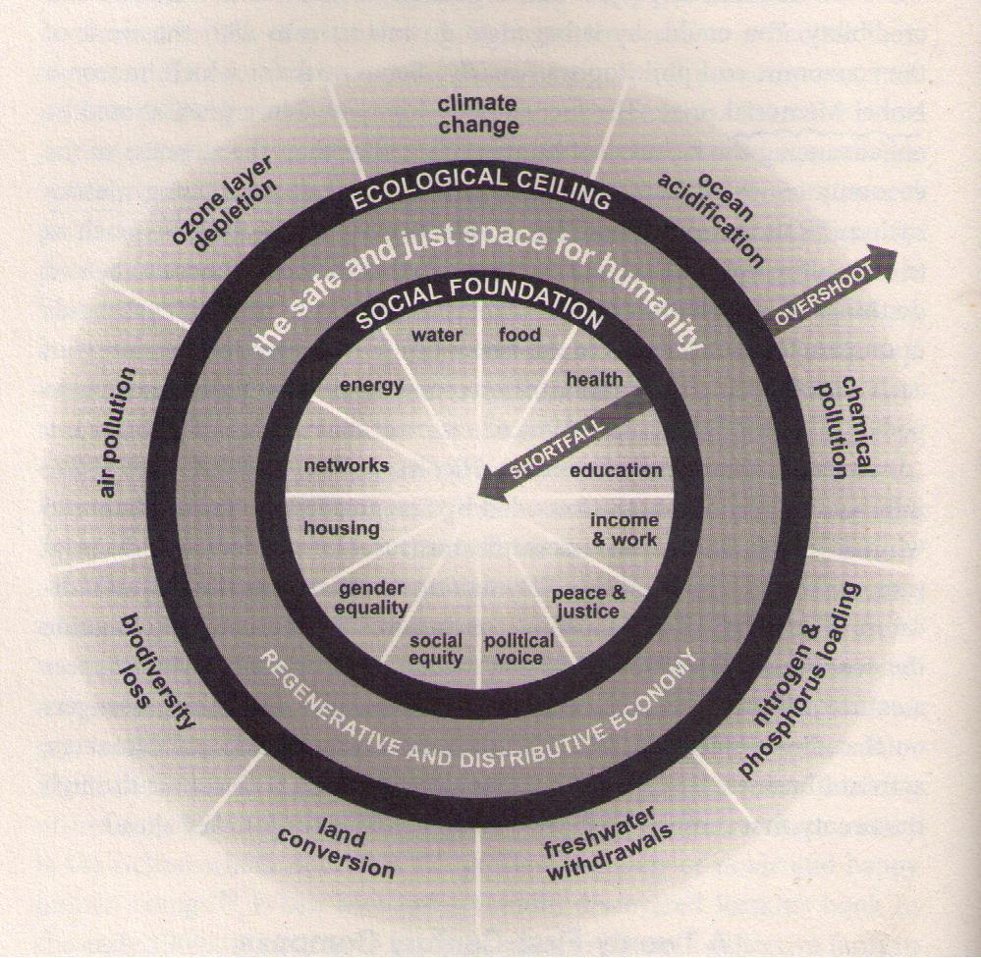

Therefore, in the doughnut’s internal empty space we have the shortfalls, which must be improved to enter the safe space of the doughnut itself and in the external empty space we have the overshoots, which we have to curb down. It is not very different from how we take care of our house, where we work to overcome the shortfalls and to control the excesses. Economics ceases to be a mystery to mathematical model lovers and starts making sense to mere mortals. At the same time, we have a simple image with challenges aligned with the decisions of the global conferences of 2015, the Climate Agreement in Paris and the 2030 Sustainable Development Goals in New York. (38-39)
The ease with which we can read and even mentally visualize the economic challenges is essential. As long as the immense majority doesn’t understand the logic behind our use of resources, the deceit will go on, including the major narrative that we need the rich to invest and generate jobs and the poor because poverty makes them work. In fact, the rich today make financial investments instead of investments in the real economy, placing their resources in tax havens. They invest very little and barely pay their taxes.
In a functioning world, the taxes on unproductive capital would lead rentists to do something useful with their wealth. And, as we have observed in all initiatives that guaranteed more resources for the bottom of the pyramid, the result is an increase in the demand, in the activity of small and medium companies, and employment growth. This, by the way, generates a greater amount of taxes and balances the public budget. One need only remember the success of the New Deal, the Welfare State, the thriving era of the Brazilian economy between 2003 and 2013, and even more recently the “Geringonça” in Portugal.
When we see which sectors and activities are depleting our planet’s natural resources and in which fields we are coming short of our needs, we can, sector by sector, channel our efforts and financial resources to where they will generate more balance.
In other words, we can calculate where we should hold back and where we should move on, which sectors are a priority and where to ensure basic conditions for the people. The economy starts making sense. Tim Jackson, who comments the book, reminds us of how absurd it is that people are “persuaded that they should spend money they don’t have, on goods they don’t need, to create impressions that won’t last on people who don’t care about it.” It is time someone brought some sense to the general view on the real economy. At the center of all answers is not a complicated model but the “the 21st century creating far more effective forms of governance, on every scale, than have been seen before”. (51)
Reducing our numbers to one synthetic indicator, GDP, is deeply misleading, and as Hazel Henderson has shown in surveys over what people think should be measured, a strong majority suggest we should measure health, education and environment progress. In Brazil, for example, 85% considered these indicators are as important as the economic ones. And redoing the math, in economics, is fundamental.

Recovering the productivity of financial resources
Good intentions, claims and declarations with elevated ethical principles won’t solve our problems if we don’t face the central issue of money being channeled to finance our priorities. It’s crucial to remember what we saw above, about the 2015 Paris conference. They committed to raising 100 billion dollars a year to face the environmental catastrophe, a ridiculous sum when compared to the 20 trillion hidden in tax havens, 200 times more. Let’s keep in mind that all big corporations and fortunes today have branches in tax havens, which are basically the result of tax evasion, corruption and money laundering. The economic system that really exists is immersed in illegality. And these are monumental volumes of resources.
A second central issue is that the world is not poor. As we saw, the world GDP is currently of 85 trillion dollars. This volume of goods and services produced in the world represents 3,700 dollars per month per four-member family. There is no way you can justify 820 million people going hungry, out of which, more than 150 million are children. Our problem is not economic but essentially ethical and political. In Brazil’s case, we are exactly on the world average mark in terms of GDP per person. There is no economic reason for poverty.
A third issue is that the fortunes growing today are essentially based on return over financial papers. With the studies of Thomas Piketty, Joseph Stiglitz, Paul Krugman, Ellen Brown, Michael Hudson, François Chesnais, Marjorie Kelly, Ted Howard, Paul Dembinski, Sam Pizzigati, Mariana Mazzucato, Hazel Henderson, Ann Pettifor and so many others, we have now a solid theoretical base and clear demonstration of the speculative mechanisms that multiply fortunes and extract resources that are indispensable to prevent the catastrophes coming ahead.
Let’s remember the basic mechanism of speculative wealth production: a billionaire who invests one billion in papers that yield a modest 5% a year is earning 137 thousand dollars a day. The next day, his fortune will yield 5% on one billion plus the previous day’s earnings and so on, without having to produce anything. The mechanism, known as the snowball effect, led to the absurd situation where the wealthiest 1% have more than the other 99%. Without producing anything. In Brazil, 6 families hold more accumulated wealth than the poorest half of the population. This clearly doesn’t work.
Jared Bernstein, former economic adviser of US vice-president Joe Biden, observes this general shift in the economic analyses, in the telling title of his study: “New economy – A generation of economists helped get us into this mess. A new generation can get us out.” According to the author, “any form of social analysis that aims to be useful to society must evolve in ways that enhance social welfare, equity, racial and gender justice, and environmental sustainability. For too long, much of economics failed that test — yet its interaction with the ruling class elevated it to a powerful perch… the pervasive damage of this interaction has cleared a path for a growing number of economists who are busy knocking the old school off its privileged perch. To which I say: It’s about time.”
Forbes magazine, in its Brazilian edition, published in 2019 a detailed list of the 206 billionaires of the country. Jorge Lemann is in the first place, with a total wealth of 104 billion Reais, based on dividends, money from other people’s money. Second, comes Joseph Safra, a bank owner, with 95 billion. Between 2018 and 2019, his fortune increased in 19.31 billion, while the Brazilian economy is in a standstill. The Marinho family, with a fortune of 34 billion, saw an increase of 9.3 billion in the same period. Cândido Pinheiro Koren de Lima, from Hapvida health services, has a total wealth of 13.82 billion, which increased by 6.22 billion during the last year. Speculating on healthcare is good business. The economy is paralyzed since the chaos leading to impeachment of president Dilma began in 2014, but the fortunes of billionaires have been growing by 11% a year.
One must search diligently to find someone who effectively produces something. They prefer to be the ones to manage financial resources. All in all, in 7 years of chaos in the financial system, we went from 74 billionaires in Brazil in 2012 to 206 in 2019. The accumulated fortunes went from 346 billion Reais to 1,205.8 billion for the same period. (p.108) Dilma’s attempt to halt speculation by reducing taxes, in 2012/2013, now shows the size of its weakness: the political influence of financial interests is immense. It is the heart of power. And the economic crisis, even before the pandemic, becomes clear: speculation is not production, money allocation in financial papers does not represent productive investment.
The fortunes mentioned don’t pay taxes, because distributed profits and dividends in Brazil are exempt from taxes since 1995. The process is not new. The saying pecunia pecuniam parit comes to us from ancient times. But with the immaterial money of today, issued by banks themselves and surfing the planet with very little control, the result is a global disaster. In Brazil, we are at a standstill for the seventh year in a row, drained by exorbitant and unproductive profits. The need for the big fortunes to pay taxes is not very hard to grasp.
The alternatives are becoming clearer. Thomas Piketty proposes measures for what he calls “participative socialism”. According to Enric Bonet’s summary, Piketty suggests that “adopting a new progressive tax on net wealth would take into account household debts and would not affect those with a property level within the country average. There would be a 1% tax on those whose wealth is double the national average, 20% for those whose wealth is 100 times above the average and with a maximum of 90% for those whose wealth is 10,000 times above the average.” The set of measures proposed by Piketty, including a “universal inheritance” and shared power in corporate administration, as is already the case in Sweden and Germany, presents a view that makes sense. It is interesting to note that Piketty characterizes his proposals as the evolution into “participative socialism”, while Stiglitz, in his more recent works, proposes “progressive capitalism”. In fact, we are simply searching for something that works.
Sam Pizzigatti’s proposals regarding the adoption of a maximum income in corporations are equally interesting. This is not far-fetched at all. The idea is to limit executives’ payments to the company’s base salary. In this way, the top level can increase its earnings only if it also increases also the lower level’s earnings. In the state of Oregon, in the US, companies whose range of payments exceeds the 1 to 20 relation are simply excluded from participation in contracts with the public sector, and many American states already require companies to make public the range of payments they practice.
The issue of tax havens regularly comes up in the G20 agenda, as well as the generalized tax evasion by the large groups and large fortunes of the world. The OECD is preparing an initial proposal for international financial regulation, in the scope of the Base Erosion and Profit Shifting (BEPS), to be presented in 2020. But the inoperability of governments and the slow pace of processes fully justify the indignation of so many young people throughout the planet. The patience is also running out among the billions of poor people who are today deprived of access to basic needs, while resources are being deviated away from their productive utilities, constituting what Marjorie Kelly and Ted Howard adequately classify as ‘extractive capitalism’. A systemic change in how we see the economy is on the agenda.
***
Even the traditional distancing and coldness of scientific analyses are losing space. We can’t avoid agreeing with Joseph Stiglitz here: “The neoliberal experiment – lower taxes on the rich, deregulation of labor and product markets, financialization, and globalization – has been a spectacular failure. Growth is lower than it was in the quarter-century after World War II, and most of it has accrued to the very top of the income scale. After decades of stagnant or even falling incomes for below them, neoliberalism must be pronounced dead and buried.”
Evidence is starting to reach even the most uninformed or ideologically distorted minds: the immense speculative fortunes must start paying taxes and the result of these taxes must be invested in recovering the planet’s sustainability and reducing inequality. And the minimum for the survival of the poorest must be ensured, starting now. We face today an absurd situation in which we know the challenges and have the corresponding financial and technological resources but at the same time postpone acting.
.
Ladislau Dowbor is a full professor of economics at the Pontifical Catholic University of São Paulo (PUC-SP), advisor to various UN agencies, and author of numerous books and technical studies, available at http://dowbor.org under the Creative Commons regime (free non-commercial use). Contact ldowbor@gmail.com
Take part in the debate by accessing www.ecofranbr.org and www.francescoeconomy.org

Bibliography
Bernstein, Jared – New Economics: A Generation of Economists Helped Get Us into This Mess. A New Generation Can Get Us Out - Vox, September 13, 2019 - https://www.vox.com/policy-and-politics/2019/9/13/20862607/economics-inequality-deregulation-wealth-taxes-policy
Bonet, Enric – Piketty e o “socialismo participativo” – IHU, outubro 2019 - http://dowbor.org/2019/10/piketty-propoe-socialismo-participativo-outras-palavras-2019-3p.html/
Brown, Ellen – Banking on the People – Democracy Collaborative, Washington, 2019
Business Round Table – Statement on the Purpose of a Corporation - file:///C:/Users/Ladislau%20Dowbor/Downloads/BRT-Statement-on-the-Purpose-of-a-Corporation-with-Signatures-1.pdf
Dowbor, Ladislau – The Age of Unproductive Capital: new architectures of power – Cambridge Scholars, 2019 - https://dowbor.org/2019/06/l-dowbor-the-age-of-unproductive-capital-new-architectures-of-power-cambridge-scholars-uk-2019.html/
Forbes – 200 bilionários brasileiros – Edição Especial – São Paulo, 2019
Henderson, Hazel – “Mapping the Global Transition to the Solar Age” – London, 2014; “Steering Societies Beyond GDP to SDGS” – 2020 https://www.ethicalmarkets.com/steering-societies-beyond-gdp-to-sdgs-by-hazel-henderson/
Kelly, Marjorie and Ted Howard –The Making of a Democratic Economy–Berrett-Koehler Publishers, Oakland, 2019
Kliass, Paulo – Cheiro de mudanças no ar – Outras Palavras, 24/set. 2019 - https://outraspalavras.net/alemdamercadoria/economia-cheiro-de-mudanca-no-ar/
Mazzucato, Mariana – The value of everything – Public Affairs, New York, 2018
Pettifor, Ann (2020) “Inequality and morbid symptoms of a financialised system.” real-world economics review, issue no. 92, 29 June, pp. 246-251, http://www.paecon.net/PAEReview/issue92/Pettifor92.pdf
Pizzigati, Sam – The Case for a Maximum Wage – Polity Press, Cambridge, UK, 2018 - https://dowbor.org/2018/10/sam-pizzigati-the-case-for-a-maximum-wage-polity-press-cambridge-uk-2018-133p.html/
Raworth, Kate - Doughnut Economics: 7 ways to think like a 21st Century Economist – Chelsea Green Publishing, 2017 – http://dowbor.org/2017/08/kate-raworth-doughnut-economics-7-ways-to-think-like-a-21st-century-economist-chelsea-green-publishing-2017-isbn-a-economia-da-rosquinha-7-maneiras.html/
Roosevelt Institute – New Rules for the 21st Century –2019 - https://dowbor.org/2019/04/roosevelt-institute-new-rules-for-the-21st-century-2019-77p.html/
Stiglitz, Joseph – After Neoliberalism – Public Syndicate, May 30, 2019 - https://www.project-syndicate.org/commentary/after-neoliberalism-progressive-capitalism-by-joseph-e-stiglitz-2019-05
Stiglitz, Joseph – Crise Civilizatória – 4 Set. 2019 - https://outraspalavras.net/crise-civilizatoria/poderia-o-capitalismo-ser-menos-brutal/
Wallace-wells, David – The uninhabitable earth – Penguin Books, New York 2019 - https://dowbor.org/2019/07/david-wallace-wells-the-uninhabitable-earth-life-after-warming-tim-duggan-books-penguin-new-york-2019.html/

Released: August 19, 2019. Updated with New Signatures: September 6, 2019 file:///C:/Users/Ladislau%20Dowbor/Downloads/BRT-Statement-on-the-Purpose-of-a-Corporation-with-Signatures-1.pdf
Banking Principles – UNEP – Sept. 23, 2019 – Assets 47tri$ https://www.unepfi.org/banking/bankingprinciples/ The Principles for Responsible Banking – See also: https://www.unepfi.org/news/industries/banking/130-banks-holding-usd-47-trillion-in-assets-commit-to-climate-action-and-sustainability/
Roosevelt Institute – New Rules for the 21st Century – 2019 – 77p. https://rooseveltinstitute.org/wp-content/uploads/2019/04/Roosevelt-Institute_2021-Report_Digital-copy.pdf
For Monbiot’s complete review in the Guardian, see http://www.monbiot.com/2017/04/13/circle-of-life/
Hazel Henderson, Most prefer expanding GDP with health, education and environmental data - https://www.ethicalmarkets.com/global-survey-finds-most-prefer-expanding-gdp-with-health-education-and-environmental-data/ See also https://www.ethicalmarkets.com/steering-our-powers-of-persuasion-toward-our-human-future/
https://www.project-syndicate.org/commentary/after-neoliberalism-progressive-capitalism-by-joseph-e-stiglitz-2019-05

